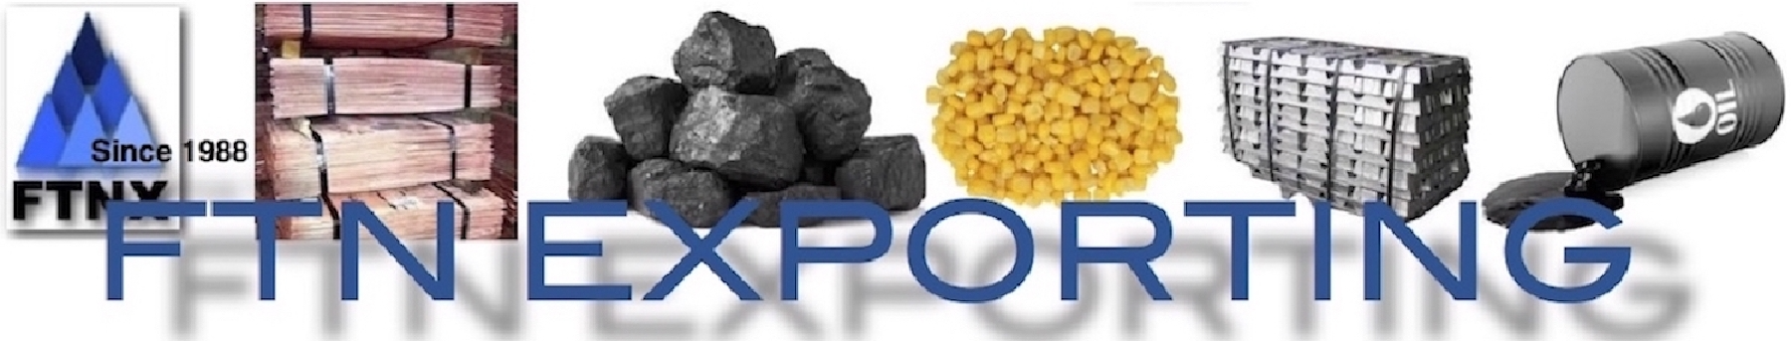
ASSURANCE OF SUPPLY (AOS) CERTIFICATE
FTNX COMMODITY INDEX
To: Davide Giovanni Papa
Buyer and CEO fan Exporting Australia
Email: ftn_smice@bigpond.com Website: www.ftnx.net

I /We the name supplier in possession of export ready goods hereby assure the supply of the product named below, should FTN Exporting via website www.ftnx.net apply to buy said product at a price supporting the Transaction Code as follows;

T/C: ___________________________

and that; the disclosed supplier is not using a SPCT endorsed member and agent of FTNX. Details of the AOS are as follow.

Corporate Name of the Supplier }
Postal Address }

Export Manager Name }

Name of Bank Accepting Payment }
Country Bank is Located In }

Validity:Assurance of Supply is Valid } From _______________ to _______________

Email Address }

Website Address }

Phone Contact }
Name of Product Assured }

Quantity Contract Total (MT) }

Quality Per Month Onboard }

Delivery Mode }

GRADE }

SPECIFICATION } Please attach full specifications

Once contracts are signed and payment has been lodged as accepted; how long will first delivery take in days }

DECLARATION OF SUPPLY
I/We named supplier herein has read the FCI index and understand the offer made therein. I/We understand that the nature of business is strictly private confidential for 5 years. I am aware that is AOS is not legally binding and agree to honour supply with good and honourable intent once an offer from FTNX has been accepted within the stated validity period indicated.The offer once accepted is legally binding.

Print Name }

Date of returning to FTNX }

Signature /Seal }

NOTE: Supplier please convert AOS PDF and return it to ftn_smice@bigpond.com email. Any questions?We will advise by email, otherwise listed product assured, will be assessed for FTNX purchase consideration within said validity period. The supplier has discretion to renew AOS should FTNX not buy goods assured goods within validity period offered .If the supplier is already in contact with a SPCT Agent, the supplier must forward this AOS to the SPCT Agent and not FTNX. FTNX is owned by the principal FTN Exporting Australia– as established 1988.FTNX is acting on behalf of undisclosed principals .Our clients are confidential and have no basis in this transactions

FTNX is unable to accept any product form a country bearing westerns economic sanction with Australia ,Canada, U.K an USA

